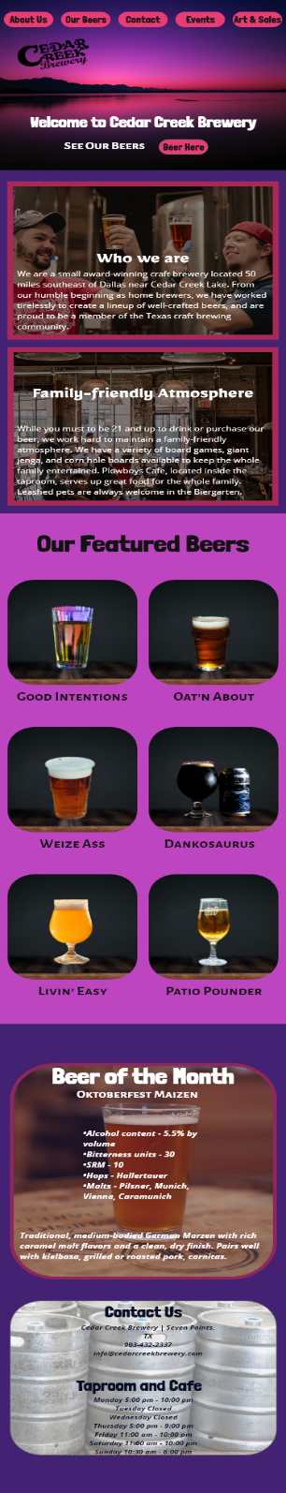Cedar Creek Brewery is the latest project I have done. On the left is a mobile layout and on the right is a desktop layout. This page is web responsive using HTML5 and CSS3. I choose darker colors that complement the main image in a simple layout.